Highside AWS CLI + K9s Setup (UMAI & CPAS)
Table of Contents

Highside AWS CLI + K9s Setup (UMAI & CPAS) 2
Part 1: AWS CLI Setup 3
1. Install Homebrew 3
2. Install Python 3.9 3
3. Create highside aws_cert folder 3
4. Create and activate a virtual environment 3
5. Install AWS CLI 3
6. Configure AWS CLI 4
7. Install Python dependencies 4
8. Run updateCerts.sh 4
9. Get your HA username + 10-hour password 4
10. Run samlapi.py 7
11. Verify AWS CLI access 10
Part 2: K9s / kubectl Setup 10
Install kubectl and k9s 10
Set up kubeconfig 10
Requesting Access (tickets) 12
ArgoCD Links 15
Bitbucket Links 15
ACR (Container Registry) Access 15
Troubleshooting 16
Daily Setup 16
Related pages 16

Highside AWS CLI + K9s Setup (UMAI & CPAS)
Last edited time: August 3, 2026 8:09 PM by Vidushi Meel
BLUF: This is the consolidated, Eagle-specific guide for getting AWS CLI + K9s/kubectl access working on your highside laptop. It replaces or acts as a renewed point of reference for the floating “AWS-CLI-set-up-documentation” file (Word/PDF passed around via Teams/email).
This doc combines the references from AWS-CLI-set-up-documentation and the highside confluence doc. If you need to reference the original copies, you can find them through Teams.

Prerequisites
- Highside laptop with Heightened Account (HA) already created (see Requesting Access section below if you don’t have one yet)
- Cluster access (heightened devrole pt 2 following this) — you should have this automatically.
- For CLI-distillery / conda / Horizon proxy setup, that’s a separate flow — see Get your Eagle Development Setup Ready Highside instead. This page is only about AWS CLI + K9s/kubectl cluster access.
- It would help to have your opencode setup already for troubleshooting!

Part 1: AWS CLI Setup

1. Install Homebrew
/bin/bash -c "$(curl -fsSL https://raw.githubusercontent.com/Homebrew/install/HEAD/install.sh)"

2. Install Python 3.9
⚠️ Warning:
Pin Python 3.9 specifically — the generic Confluence doc just says “install python3” with no version pin, but the Eagle virtual environment setup expects 3.9 and things may not work as expected on other versions.
brew install python@3.9

3. Create highside aws_cert folder
Go to this link highside (wellpoint folder) and download the Aws_Cert folder which will include:
- samlapi.py
- root.pem — the copy from Get your Eagle Development Setup Ready Highside is not the one you need for this folder, you need the one from wellpoint folder.
- updateCerts.sh

4. Create and activate a virtual environment
cd ~/aws_cert
pip install --user virtualenv --cert root.pem
/Users/{AMxxxx}/Library/Python/2.7/bin/virtualenv -p python3.9 sandbox
cp samlapi.py root.pem updateCerts.sh sandbox/
cd sandbox
source bin/activate

5. Install AWS CLI
pip install --upgrade awscli --cert root.pem
aws --version

6. Configure AWS CLI
Run aws configure once to create ~/.aws/config, then edit that file with nano ~/.aws/config directly to add the Distyl-specific profile blocks below exactly as written (except your own username):
[profile elv-distyl-gold]
aws_secret_access_key = default
aws_access_key_id = default
region = us-east-1
output = json
role_arn = arn:aws:iam::307946675711:role/gld-apm1080697-devrole
source_profile = elv-distyl-gold
[profile crln-distyl-gold]
aws_secret_access_key = default
aws_access_key_id = default
region = us-east-1
output = json
role_arn = arn:aws:iam::307946675711:role/gld-apm1082082-devrole
source_profile = crln-distyl-gold

7. Install Python dependencies
pip3 install boto boto3 requests configparser bs4 --cert root.pem

8. Run updateCerts.sh
chmod +x updateCerts.sh
./updateCerts.sh
This appends root.pem to the various cacert bundles inside your virtual environment’s installed packages.

9. Get your HA username + 10-hour password
- Log into CyberArk (have to use this link highside) — username is your AM… and follow okta login.
- Store the temporary password & account name in macOS Keychain for the script to access:
- Keychain Access → File → New Password Item → name it USHA, account = your HA account, password = today’s temporary password. See image:
- 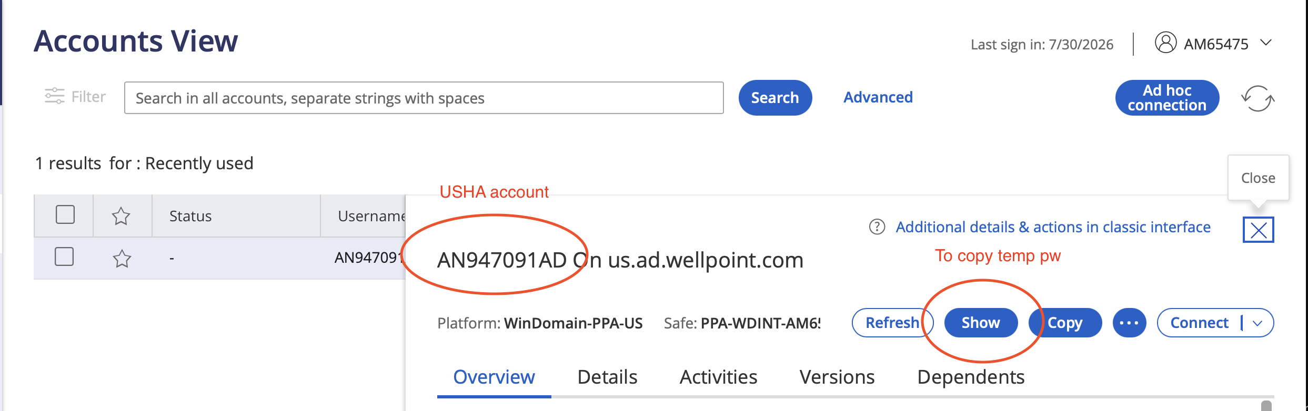
- 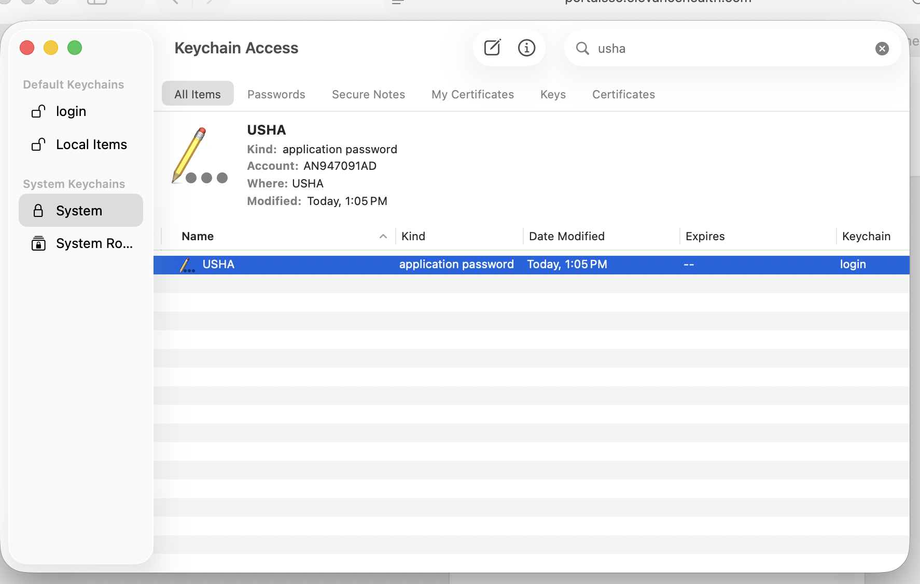
- 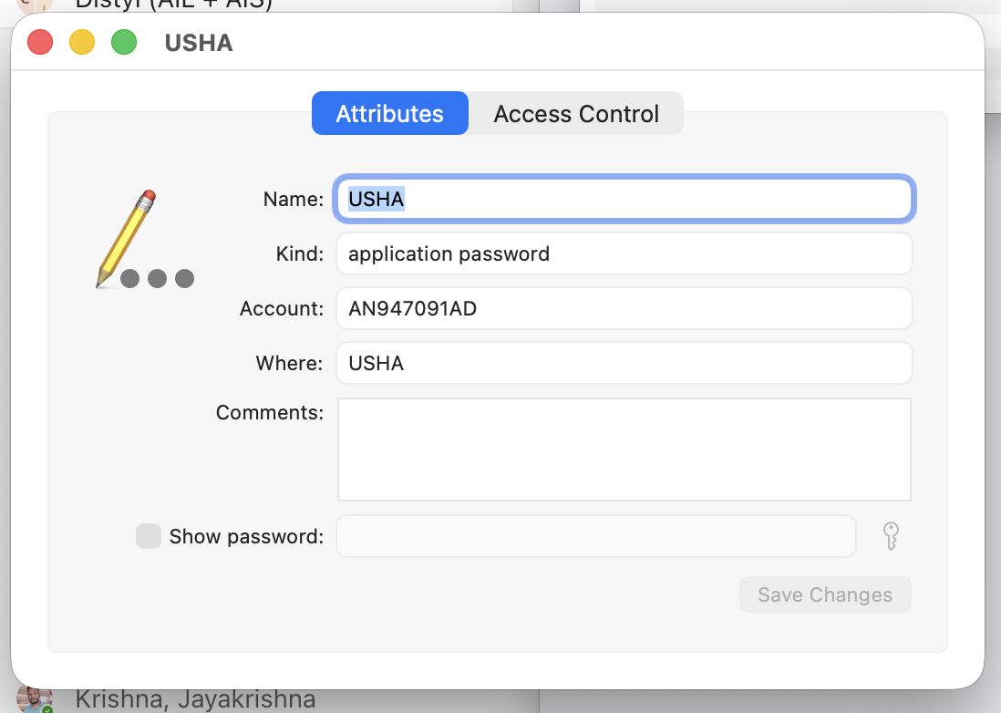
NOTE
Do not change any other thing in this command except for the username and password (see image above, username is starting from AN… and not AM. The password is something that you can copy once you click on the show button).
- This password expires roughly every 10 hours — you’ll need to update the Keychain entry (and re-run samlapi.py below) each time it expires (every time you access k9s or aws).

10. Run samlapi.py
Make sure you are in virtual environment.
Go to your virtual env folder and then activate the virtual env. The password to use in the commands below is from CyberArk.
Activate with: source bin/activate
For UMAI UAT:
python3 samlapi.py 'ANXXXXXAD@us.ad.wellpoint.com' 'PASSWORD' arn:aws:iam::738234568511:role/gld-apm1080697-devrole elv-distyl-gold us-east-1
For CPAS UAT:
python3 samlapi.py 'ANXXXXXAD@us.ad.wellpoint.com' 'PASSWORD' arn:aws:iam::738234568511:role/gld-apm1082082-devrole crln-distyl-gold us-east-1
⚠️ Warning:
Note this uses account 738234568511, while the Confluence docs sometimes use 307946675711 for the same role name. Use the one starting with 732…

Once this works, run k9s and see Eagle K9s Cheat Sheet (this is a lowside notion link) for namespace/pod navigation and shortcuts. You can also configure it for the rest of the clusters now.
NOTE
- Replace the username and password with yours that you would obtain from the CyberArk website.
- If you get SSL related errors, do: export AWS_CA_BUNDLE="path to your root.pem file”
- The Password changes every 10hrs or so, so one would have to run the command every time to get access to the cluster

Add login types
Add login-uat/login-cpas shell functions that read the password from Keychain automatically instead of typing the command above each time.
Do nano ~/.zshrc
Then add this to it:
login-uat() {
local username='ANXXXXAD'
local user='ANXXXXAD@us.ad.wellpoint.com'
local role_arn='arn:aws:iam::738234568511:role/gld-apm108097-devrole'
local app='elv-distyl-gold'
local region='us-east-1'
local pass="${1:-}"
if [[ -z "$pass" ]]; then
if ! pass=$(security find-generic-password -a "$username" -s USHA -w 2>/dev/null); then
echo "Keychain entry not found for $user (service USHA)" >&2
return 1
fi
fi
python3 samlapi.py "$user" "$pass" "$role_arn" "$app" "$region"
}
login-cpas() {
local username='AN849445AD'
local user='AN849445AD@us.ad.wellpoint.com'
local role_arn='arn:aws:iam::738234568511:role/gld-apm1082082-devrole'
local app='crln-distyl-gold'
local region='us-east-1'
local pass
if ! pass=$(security find-generic-password -a "$username" -s USHA -w 2>/dev/null); then
echo "Keychain entry not found for $user (service USHA)" >&2
return 1
fi
python3.9 samlapi.py "$user" "$pass" "$role_arn" "$app" "$region"
}
Restart your terminal and then in bash you can use commands like “login-cpas” and “login-umai” to get the relevant tokens. Prerequisite is to replace your USERNAME and add USHA to keychain setup.

11. Verify AWS CLI access
aws s3 ls --profile elv-distyl-gold

Part 2: K9s / kubectl Setup

Install kubectl and k9s
brew install kubectl k9s

Set up kubeconfig
Download the relevant kubeconfig files from here (accessible highside) and point KUBECONFIG at it:
Cluster | Kubeconfig
UMAI UAT | distyl_gold_config.yaml
CPAS UAT | carelon-distyl-non-prod.yaml
UMAI Platinum (read-only) | platinum-read-config.yaml
CPAS Platinum (read-only) | cpas-platinum-read-config.yaml

Try one and then the rest.
For instance,
Get link to the file for UMAI UAT: distyl_gold_config from the link above.
Update the KUBECONFIG to point to this kube configuration when accessing UMAI UAT.
export KUBECONFIG='path_to_virtual /distyl_gold_config.yaml’
This is the generic command for all of them:
export KUBECONFIG='path_to_virtual_env/CONFIG_NAME.yaml'
Once you’ve done that for one of them, try this:
aws eks update-kubeconfig --name distyl-gold --region us-east-1 --profile elv-distyl-gold
and this:
kubectl get pods -n umsvc-perf-gold
For any concerns drop a message in #eagle-eng on Slack.
PRO TIP:
You can use a shell script to perform the same steps.
#!/bin/bash
read -sp "Enter password: " PASSWORD
echo
cd ~/awscerts
sleep 2
ls
cd distyl-sandbox
sleep 2
ls
source bin/activate
sleep 2
python3.12 ~/awscerts/distyl-sandbox/samlapi.py 'AN814955AD@us.ad.wellpoint.com' "$PASSWORD" arn:aws:iam::738234568511:role/gld-apm1080697-devrole elv-distyl-gold us-east-1
sleep 2
aws eks update-kubeconfig --name distyl-gold --region us-east-1 --profile elv-distyl-gold
sleep 2
kubectl get namespaces

PLAT Environments:
To access Platinum, download the following kubeconfig files from the kubeconfig highside folder:
- UMAI Kubeconfig: platinum-read-config.yaml
- CPAS Kubeconfig: cpas-platinum-read-config.yaml
Update the KUBECONFIG path to point to relevant file and then go ahead with the normal kubectl/k9s command. NOTE: To access the Distyl Platinum one does not need Heighted Account or the AWS CLI or go through the above steps that are mentioned above in the docx. There are only three steps to access the platinum which are as follows:
- Download the kubeconfig
- Update the export path for kubeconfig
- Use kubectl/k9

Requesting Access (tickets)

Heightened Account (HA) creation
Sample ticket: RITM25418959 via Elevance SNOW — Request Type: New Access, Environment: Production, Access Type: General User Access.
USAD:
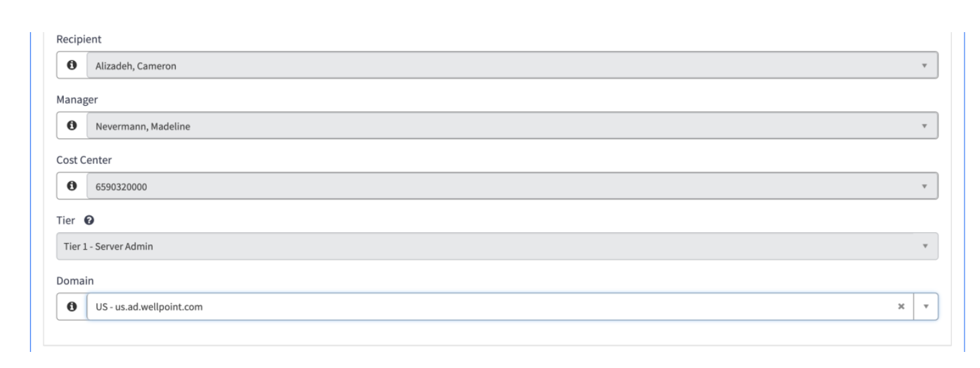
DEVAD:
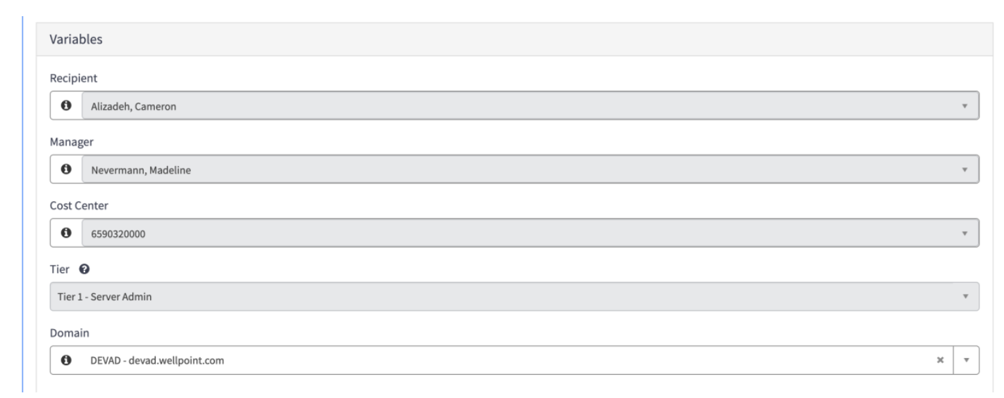

BitBucket access
Sample ticket: RITM25471043 via Elevance SNOW — Access Type: New Access, Environment: Production, Access Type: General User Access.
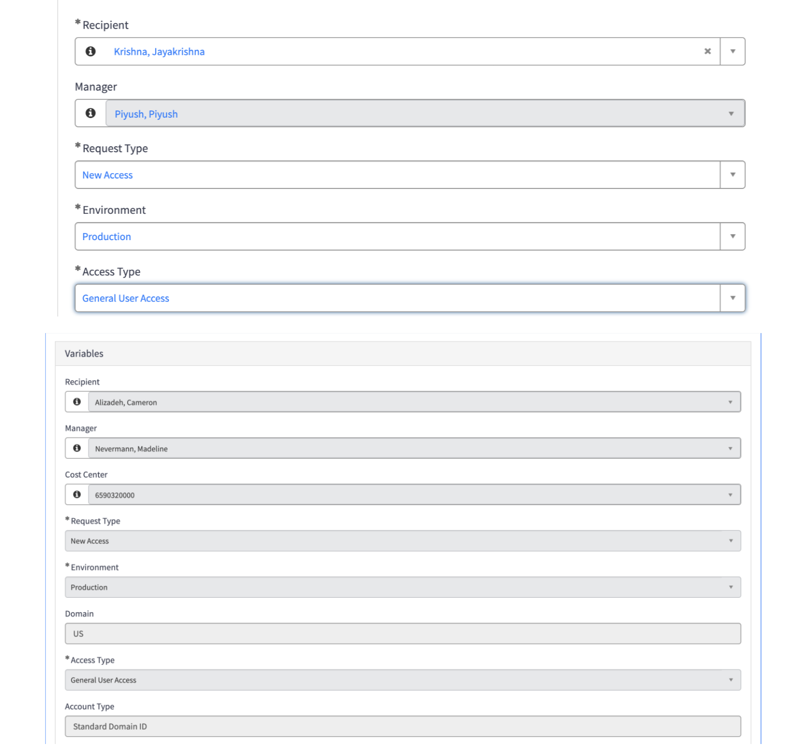

K8s cluster AD group access
Heightened accounts alone only cover k9s access — you also need to be added to AD groups on the cluster. Request via the “Network Active Directory Group User Access” ticket in Elevance SNOW if you don’t automatically have access:
- CAW-738234568511-gld-apm1080697-devrole — write access to dev/perf/uat
- CAW-738234568511-plat-apm1080697-devrole-readonly — read-only access to plat

ArgoCD Links
ALL ARGOCD Links are in 1password under Eagle group. Bitbucket links can also be found on References Doc.

Bitbucket Links
- UMAI DEV/PERF/UAT
Bitbucket link: https://bitbucket.elevancehealth.com/projects/DISTYL/repos/distyl-gitops/browse/deployment/overlays?at=distyl
- CPAS DEV
https://bitbucket.elevancehealth.com/projects/DISTYL/repos/cpas-distyl-gitops/browse?at=cpas-distyl
- CPAS UAT
https://bitbucket.elevancehealth.com/projects/DISTYL/repos/cpas-distyl-gitops/browse?at=cpas-distyl
- CPAS PLAT
https://bitbucket.elevancehealth.com/projects/DISTYL/repos/cpas-distyl-gitops/browse?at=cpas-distyl

ACR (Container Registry) Access
To log into the distylelevance Azure Container Registry, look up your own credentials rather than asking around for a shared login:
az acr credential show -n distylelevance
Source

Troubleshooting
SSL errors (SSLCertVerificationError, self-signed certificate in certificate chain) — make sure you ran updateCerts.sh (step 8), or export AWS_CA_BUNDLE="path to your root.pem" directly.
samlapi.py fails with IndexError: list index out of range on awsroles[0].split(',')[0] — this means your AWS roles list came back empty, i.e. you’re missing the K8s cluster AD group access (see Requesting Access above). Heightened account alone isn’t enough.
AssumeRole AccessDenied when running aws eks update-kubeconfig — if you get an AccessDenied error on sts:AssumeRole (AWS CLI trying to assume a role via a stale/personal IAM session instead of the org role), re-run samlapi.py (step 10) and redo the setup from there — this resets which role gets assumed and usually clears the error. Source
10-hour password expired — CyberArk passwords expire roughly every 10 hours. Update the Keychain USHA entry with the new password and re-run samlapi.py (step 10).

Daily Setup
This is for if you’ve already gone through the instructions and need to recover access day to day because of expired tokens!
Try aws sts get-caller identity. If you get ExpiredToken, first make sure your secret is updated in USHA. Then, run the python3 samlapi.py… — this command.

Related pages
- Eagle K9s Cheat Sheet — day-to-day k9s usage once this setup is done
- Get your Eagle Development Setup Ready Highside — separate cli-distillery / conda / Horizon proxy setup
- Eagle Tech Instructions Hub — Eagle Tech Instructions Hub

